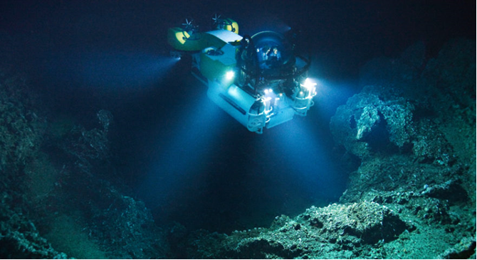

Game Design Document

Team Dragon

Alex Feetham, Courtney Daniels, Simon Harris, Rebecca Bradburn, Krzysztof Chwiolka BSc Games Technology | 05/12/2019……………..

Contents

Project Overview 2

Setting 2

Core Mechanics 2

Target Platforms 2

Target Audience 3

Scope 3

The Team and Roles 3

Research 4

Non-Virtual Reality Games 4

Ecco the Dolphin 4

Subnautica 5

Song of the deep 5

Virtual Reality Games 6

Titanic VR 6

Subnautica: Below Zero 6

theBlu 7

The Deep 7

Findings 8

# Project Overview

## Setting

The Mariana Trench expedition will be an underwater explorative experience. Located in the Pacific Ocean, the Mariana Trench is the deepest known underwater trench on the planet and contains many different rare and amazing species of sea life.

Only a handful people have had the opportunity to explore the trench, this VR experience aims to change this and make an immersive and educational experience that will be accessible to many.

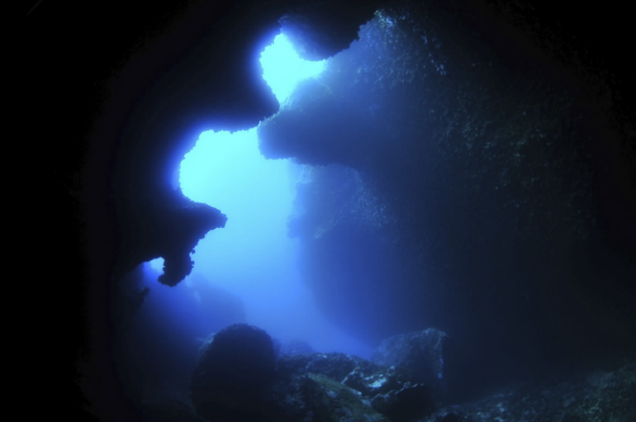

Image 1 Challenger Deep

## Core Mechanics

* Controlled spline movement (attached to a winch) for first half of experience.
  + Player will be able to move freely within a small area for second half.
* Camera will show a first-person perspective
  + User can highlight sea life or structures using controllers.
  + Focusing on sea life or structures will be produce either narrated or visual dialog that will show interesting information about the item being focused on.
* User controlled lighting will give the user a feel of as they are winched deeper and deeper into the darkness of the Mariana Trench.

## Target Platforms

* Oculus Quest / Rift / Go
* Android
* PC

## Target Audience

The experience will mainly be targeted towards children and young adults interested in marine biology. It will be designed as an educational resource that both teaches the users about marine life and introduces first-time users to the capabilities of VR, the experience could potentially be useful to both museums and classrooms.

## Scope

Each stage of the project has been carefully planned out using a Gantt chart, this will give an us an idea as to how long each task should take.

The project is being further managed through the use of an online repository for the development of the project, this will allow all of the team members to access the project easily.

For both cost and timing related issues, we are planning to create and source as many assets as possible for free, this will require finding royalty free audio and assets which will be used to fill the scene. For any assets that cannot be sourced, we will be required to either create new assets or modify pre-existing ones.

## The Team and Roles

**Krzysztof Chwiolka**

Core mechanics.

**Simon Harris**

Audio designer/engineer & core concept design.

Designer/project leader for front end.

**Courtney Daniels**

Project leader for back end.

Camera functionality.

VFX.

**Rebecca Bradburn**

Asset acquisition / level design.

**Alex Feetham**

Gameplay / Controls.

Documentation.

# Research

## Non-Virtual Reality Games

### Ecco the Dolphin

* Platform – Sega
* Art Style – 2D
* Underwater based game where a dolphin uses sonar to save other dolphins.

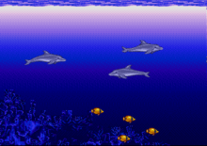

Image 2 Ecc0 the Dolphin

### Subnautica

* Platform – PC.
* Art Style – 3D.
* Underwater game based on underwater survival.

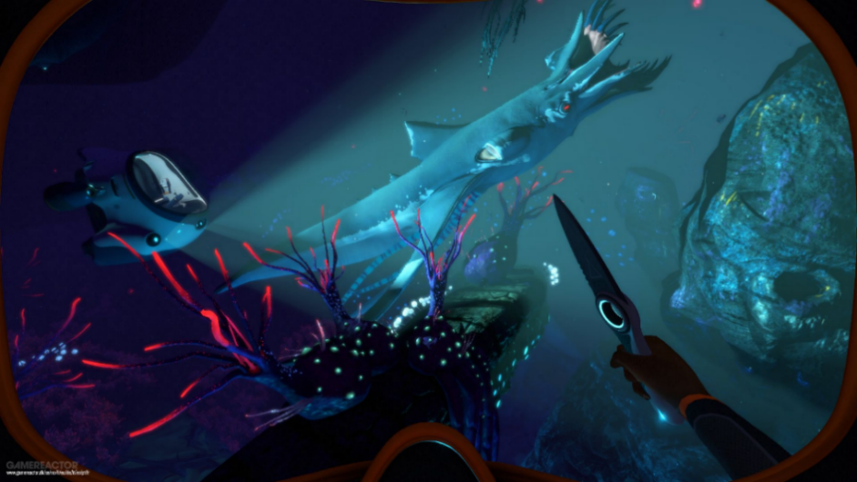

Image 3 Subnautica

### Song of the deep

* Indie game for PC.
* Art Style – 2D
* Underwater platform action game.

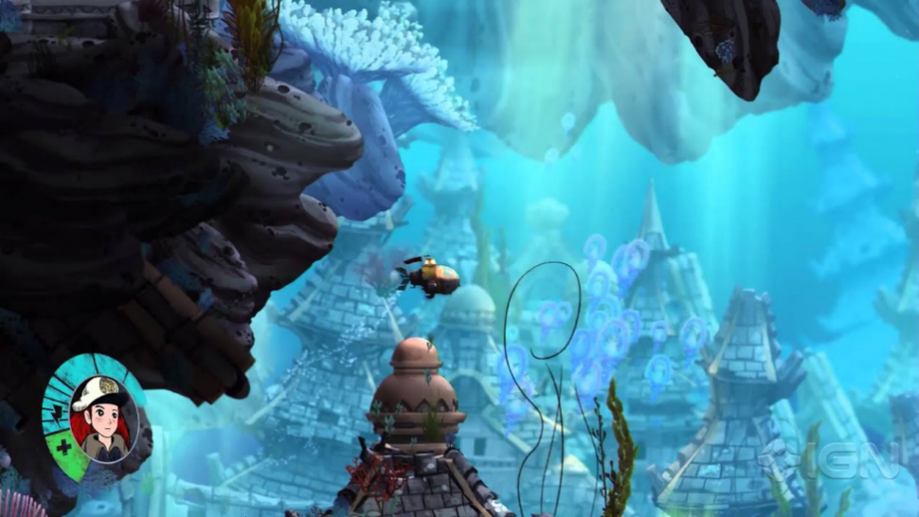

Image 4 Song of the Deep

## Virtual Reality Games

### Titanic VR

* Platform – PC
* Art Style – 3D
* Underwater submarine exploration of the SS Titanic

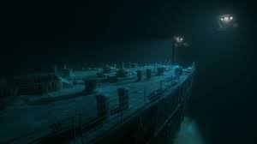

Image 5 Titanic VR

### Subnautica: Below Zero

* Platform – PC
* Art Style – 3D
* Underwater game based on underwater survival with elements of horror.

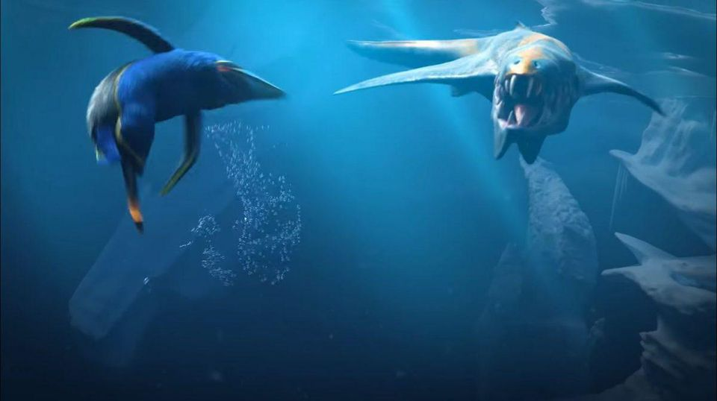

Image 6 Subnautica: Below Zero

### theBlu

* Platform – PC
* Art Style – 3D
* Underwater game based on underwater survival with a horror theme

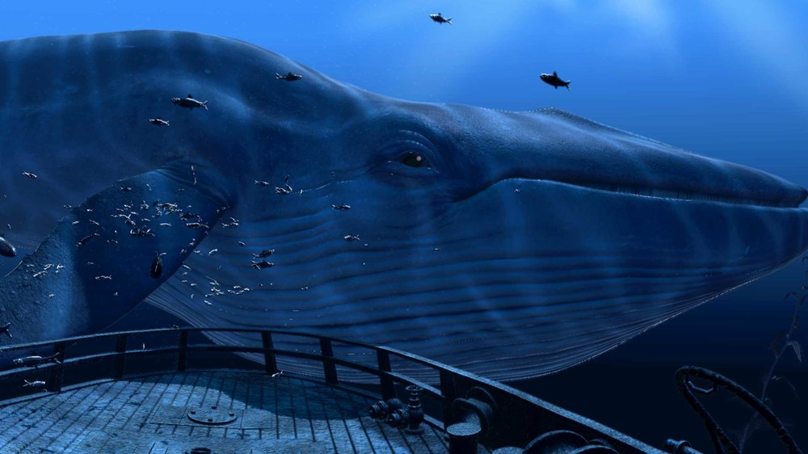

Image 7 theBlu

### The Deep

* Platform – PlayStation VR
* 3D
* Underwater game based on underwater survival with elements of horror

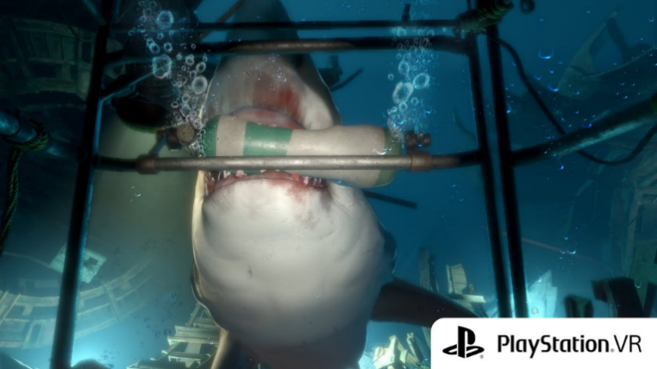

Image 8 The Deep

## Findings

A common theme amongst these examples is that many of them involve an element of horror, this is especially the case for the VR examples. Even though there may be no intention of inciting fear in our experience, the user may still feel uneasy as many of the above examples shown above are horror based.

Our project aims to avoid instigating a sense of fear, the experience will instead be focused on educating the user about the different species and structures that can be found within the Mariana Trench as they descend towards the seabed. The user will also have full control over the lighting so that they can continue their discovery, deep within the depths of the Trench.

# Our Project

## Elevator Pitch

An underwater adventure experience where the user explores Challenger Deep, an area within the Mariana Trench. They will be travelling in a submarine and will be tasked with picking up samples from the ocean floor.

## Detailed Description

The Mariana Trench expedition is an underwater adventure. The Mariana Trench is the deepest underwater trench that we know of, with less than a handful people having been down there and experienced what lies within, we wanted to create an experience that made this opportunity more accessible.

We want to provide users access to a rare experience by simulating the Mariana Trench in a 3D environment and providing them with an immersive experience in which they will be able to see rare underwater life, ship wrecks lost for decades, and experience the very depths of the deepest known place on earth.

We also want the project to be educational. We would like to use it to help get children interested in marine biology and marine conservation. One of the things found in the Challenger Deep exploration, almost 11 thousand meters deep, was a plastic bag! We want our project to also educate people about this because it is a huge problem globally and affects all of us.

## What makes this project unique?

Our project aims to create an immersive experience with a focus on adventure, education, realism and exploration. We are trying to make what is very much a ‘rare experience’ accessible to everyone. A very small amount of people would ever get the opportunity in life to do this for real and we want to make it available to everyone.

# Story and Gameplay

## Story

The experience starts with the user being inside a submarine that is connected to a boat.

Once released, they will be placed into the water and slowly lowered to the sea floor whilst attached to a winch (Realistically this would take around an hour), we will use fading between scenes to show the passage of time and speed the journey up.

Once the sub has landed on the seabed, the player will be disconnected from the winch and will be able to explore a section of the seabed for a limited time. Once this time is up, the player will be reconnected to the winch and will begin their ascent towards the surface of the ocean.

## Event Map

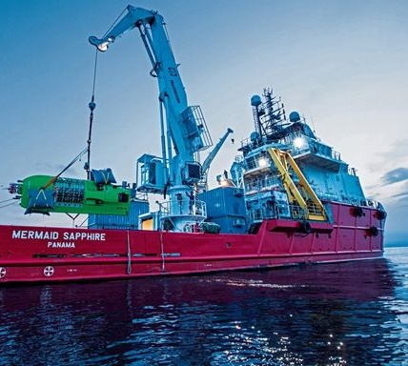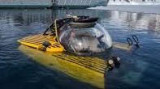

The experience will begin with the submarine above water onboard the research ship

The submarine will then be dropped into the ocean

[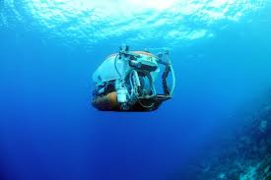](https://www.google.co.uk/imgres?imgurl=https%3A%2F%2Fwww.telegraph.co.uk%2Fcontent%2Fdam%2FTravel%2F2017%2FNovember%2Fdeep-sea-curacao.jpg%3Fimwidth%3D450&imgrefurl=https%3A%2F%2Fwww.telegraph.co.uk%2Ftravel%2Factivity-and-adventure%2Fhow-to-dive-to-the-deep-sea%2F&docid=rmUPnMzamuD2wM&tbnid=nMcoZ7tmLlMglM%3A&vet=10ahUKEwjtzrSlm6zmAhXMiVwKHaq9BzsQMwiYASg2MDY..i&w=480&h=319&bih=655&biw=1366&q=submarine%20beggining%20descent&ved=0ahUKEwjtzrSlm6zmAhXMiVwKHaq9BzsQMwiYASg2MDY&iact=mrc&uact=8)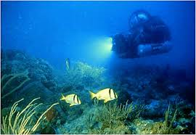

The descent begins…

The submarine will be winched down to the seabed

The user will have the chance to learn about various species as the descend into Challenger Deep

[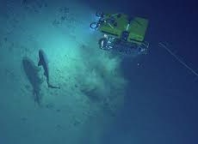](https://www.google.co.uk/imgres?imgurl=http%3A%2F%2Finnerspacecenter.org%2Fwp-content%2Fuploads%2F2016%2F07%2FNaut6SharkFrArgusFB.jpg&imgrefurl=https%3A%2F%2Finnerspacecenter.org%2F2017%2F01%2Fwhat-is-an-rov%2F&docid=auJWlClGkwWHNM&tbnid=aR1vMkNiI2hnJM%3A&vet=10ahUKEwi-gdiunKzmAhWBtHEKHaiaC7YQMwiBASgkMCQ..i&w=960&h=539&bih=655&biw=1366&q=ocean%20exploration&ved=0ahUKEwi-gdiunKzmAhWBtHEKHaiaC7YQMwiBASgkMCQ&iact=mrc&uact=8)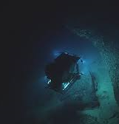

The types of sea life present will vary depending on the depth

The environment will gradually get darker the further the sub dives

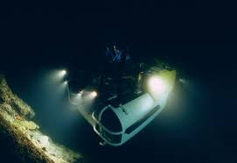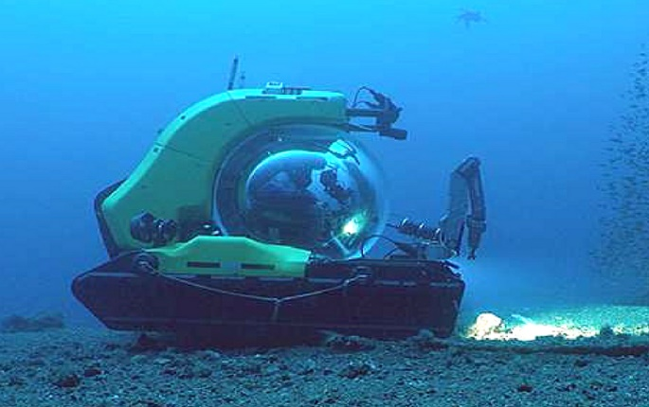

At the deepest parts, the environment is pitch black. The user will need to toggle on/off the submarine’s lights

After travelling through carious depths, the user will land on the seabed which they can explore before resurfacing

## Mood Board

The following collection of images aims to showcase how the experience should look to the user and shows a range of sea life and environmental structures that they should expect to see on their journey.

The following images are sourced from actual expeditions that are documented on the website of the National Oceanic and Atmospheric Administration. Available from: <https://oceanexplorer.noaa.gov/okeanos/explorations/ex1605/welcome.html>

### Sea Life

**Starfish**

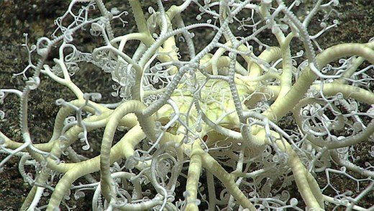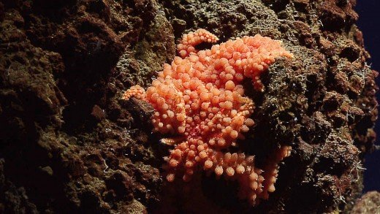

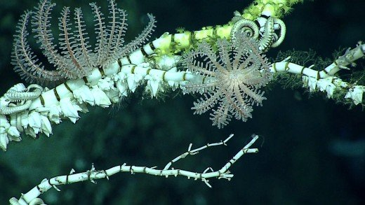

**Barnacles**

[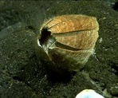](https://www.ncei.noaa.gov/waf/okeanos-animal-guide/Cirripedia029.html)[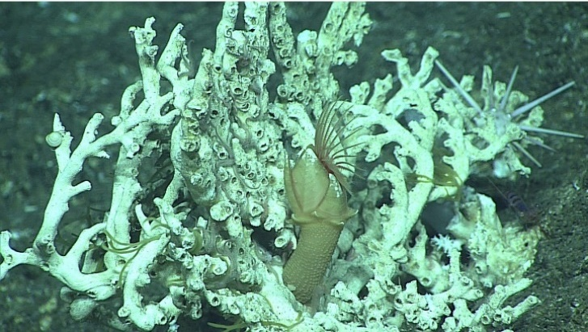](https://www.ncei.noaa.gov/waf/okeanos-animal-guide/images/Cirripedia021.jpg)

**Crabs**

[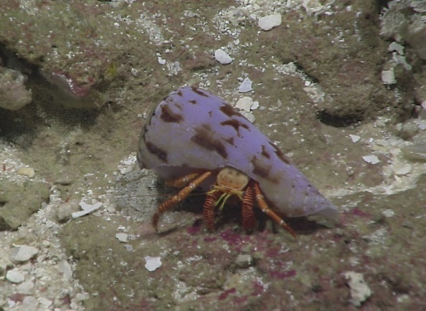](https://www.ncei.noaa.gov/waf/okeanos-animal-guide/images/Paguroidea001.jpg)[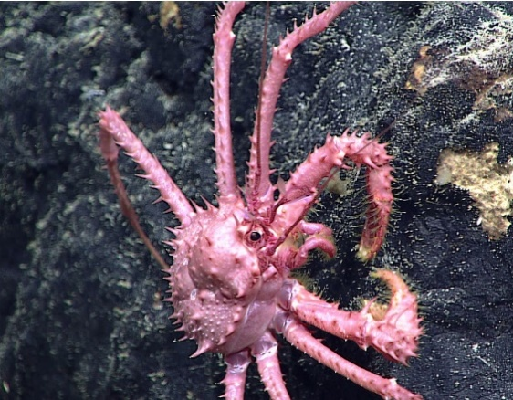](https://www.ncei.noaa.gov/waf/okeanos-animal-guide/images/Lithodoidea014.jpg)

**Sharks**

[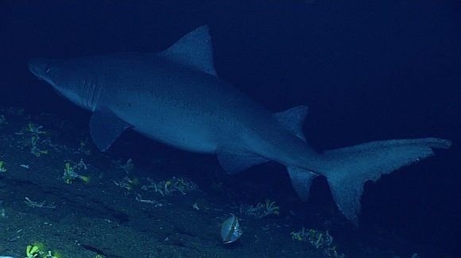](https://www.ncei.noaa.gov/waf/okeanos-animal-guide/images/Selachii012.jpg)[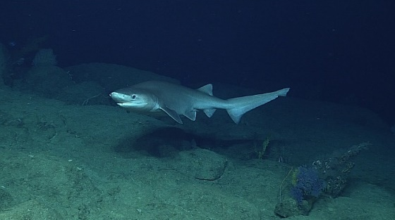](https://www.ncei.noaa.gov/waf/okeanos-animal-guide/images/Selachii006.jpg)

**Deep Sea Creatures**

[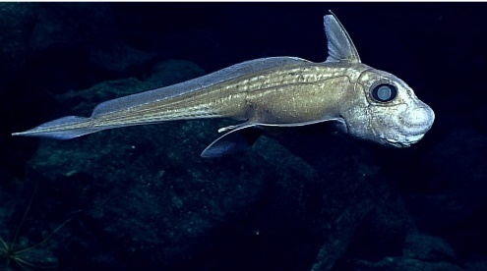](https://www.ncei.noaa.gov/waf/okeanos-animal-guide/images/Chimaeriformes003.jpg)[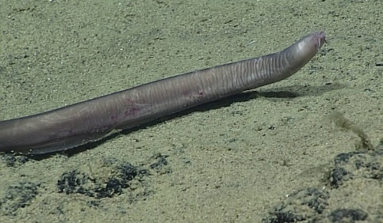](https://www.ncei.noaa.gov/waf/okeanos-animal-guide/images/Myxini002.jpg)

[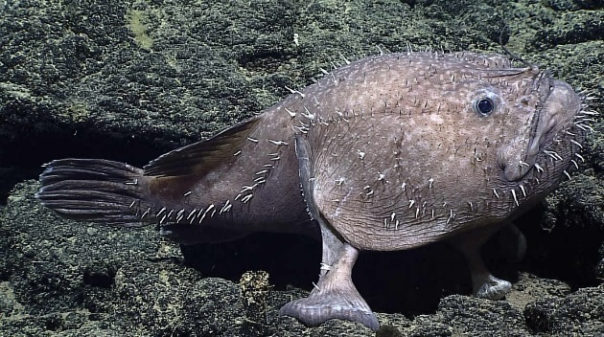](https://www.ncei.noaa.gov/waf/okeanos-animal-guide/images/Lophiiformes037.jpg)

### Environment

**Corals**

[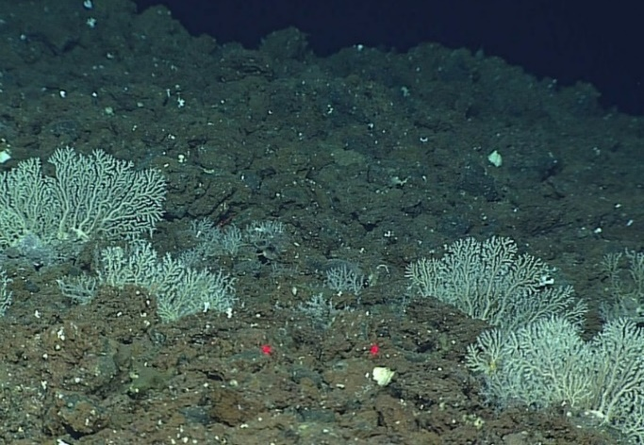](https://www.ncei.noaa.gov/waf/okeanos-animal-guide/images/HydrozoaCoral-like005.jpg)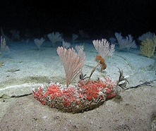

**Shipwrecks / Aircraft Wreckage**

[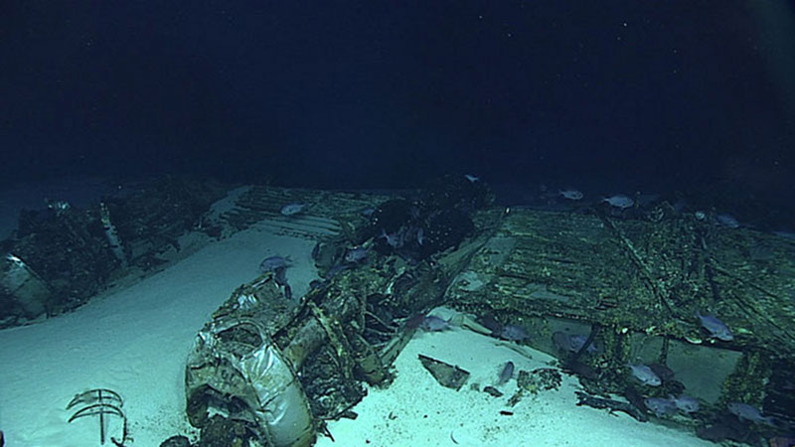](https://oceanexplorer.noaa.gov/okeanos/explorations/ex1605/logs/jul9/media/1605b29-wreck-hires.jpg)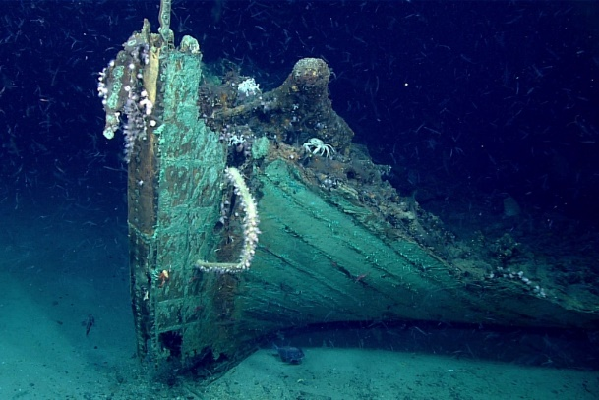

**Hydrothermal Vents / Underwater Volcanoes**

[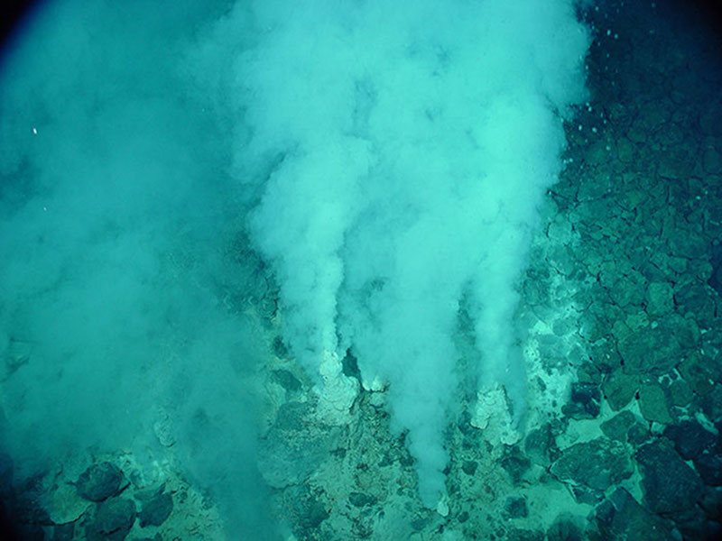](https://oceanexplorer.noaa.gov/okeanos/explorations/ex1605/background/vents/media/champagne-hires.jpg)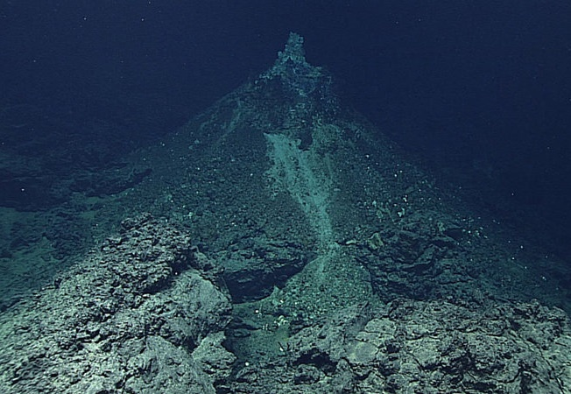

# Additional Components

## Assets

All assets below are royalty free assets from TurboSquid. We plan to use these assets and create our own.

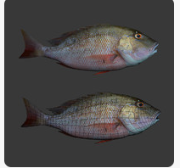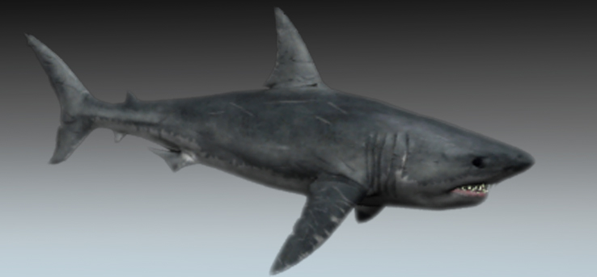

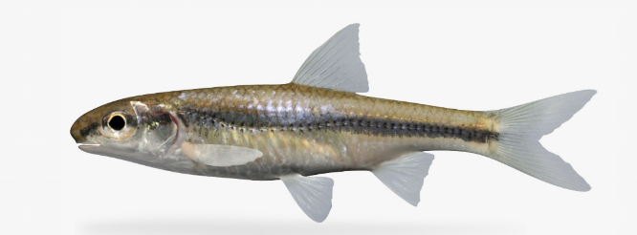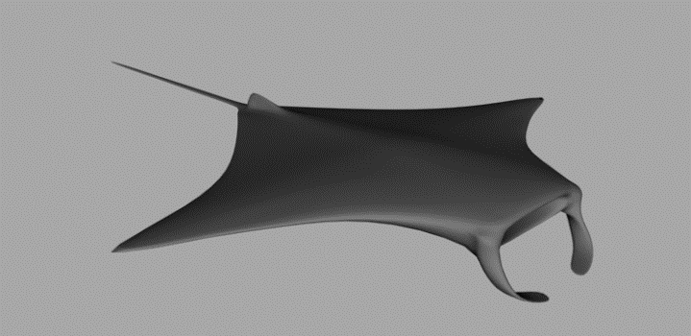

## Textures

We will need a lot of different textures for the different assets we will be including.

**Submarine Textures:**

* Glass
* Metal
* Plastics

**Sea Life:**

* Fish Scales
* Fisheye Textures

**Environment Textures:**

* Sand
* Water
* Seaweed
* Rocks
* Lava

**Ship Textures:**

* Glass
* Metal
* Plastics

## Characters

Main character – Submarine Driver/Passenger – Sven Anderson.

Narrator – Boat Captain – Ivor Cholesky.

Radio comms – Communication operator – Andrea Barbro.

## Scripts

* Character movement script – Script created for basic character movement within the sub.
* Submarine movement script – Script movement for submarine sea floor.
* Ai movement script – Movement of AI script for marine life.
* AI interaction script – Interaction with AI (Sea life).
* Water sound Diffraction script – A script which helps create the effect of audio within water.
* Lighting script – Script for controlling the sunlight through water.
* Submarine lighting script – Script to control lights on Submarine.
* Player interaction script – Script for controlling players interactions with the submarine.

## User Interface

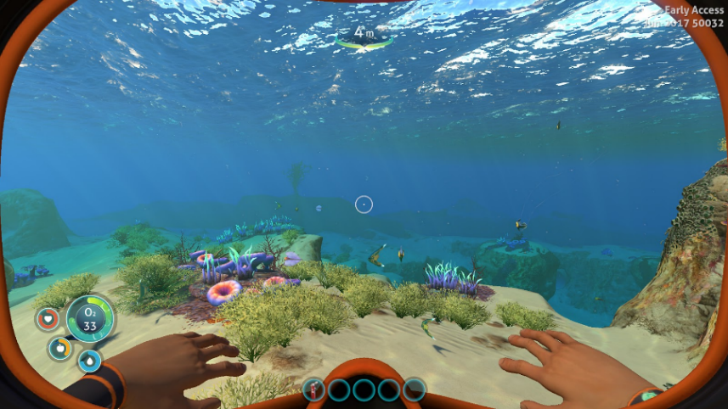We have planned to have UI which will show educational information about the fish and surrounding area. We will also display the depth reached to the user. We are planning to use a UI layout to constantly show the user the depth they are currently at. As well as this, instead of showing oxygen levels on the UI, we will be showing the user the levels of pressure outside of the submarine (educational). For UI patterns it is always important to have a centre of screen indicator to help first time users in VR.